**Resiliency Dashboard Tableau Consumption**

**Steps:**

1. Login to Tableau Server
2. Select “Server Status” option from  menu on left hand side

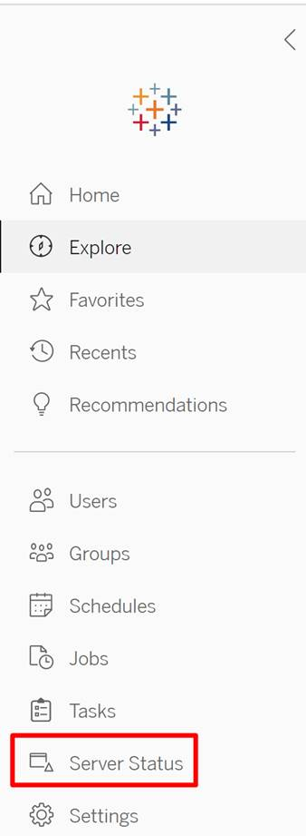

1. Under “Analysis”, select “Action by Specific User” dashboard:

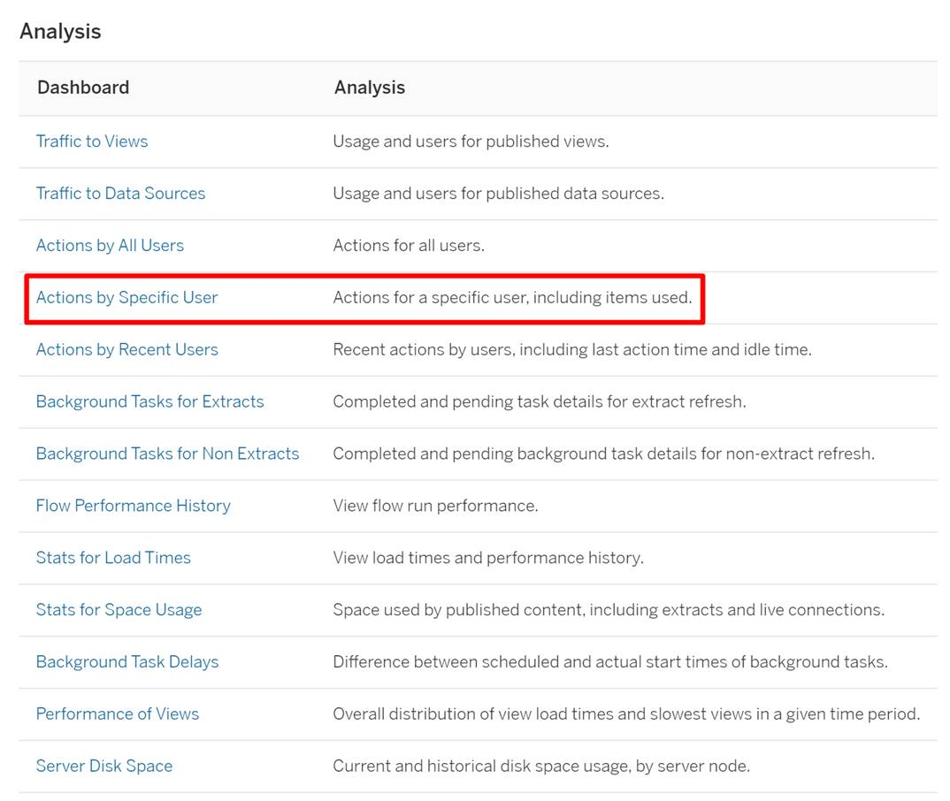

1. To get the report of “# of logins to tableau server”, select “Login” in the “Action” filter

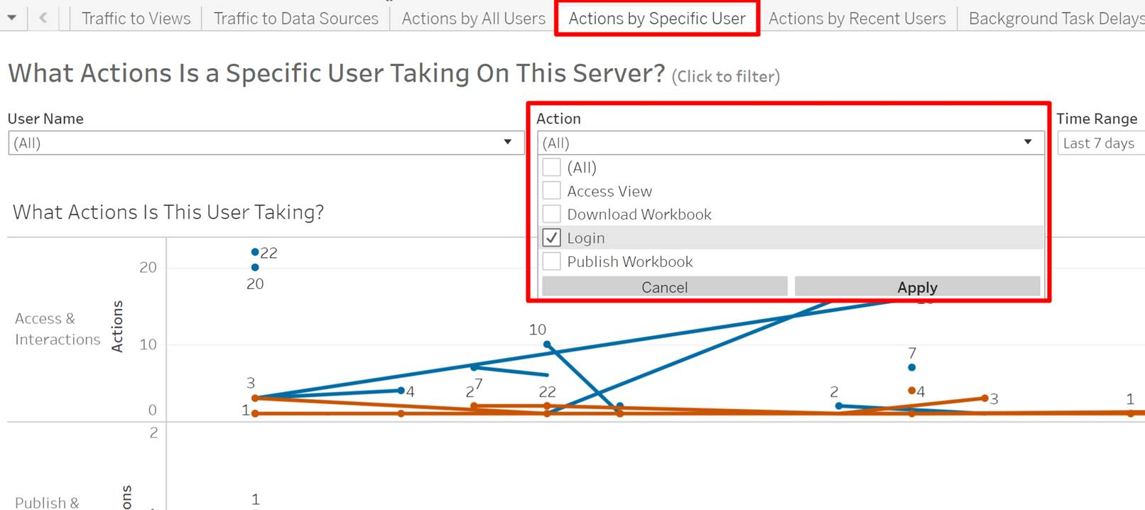

1. Similarly, to track “users specific action”, filter the report for “Access View”:

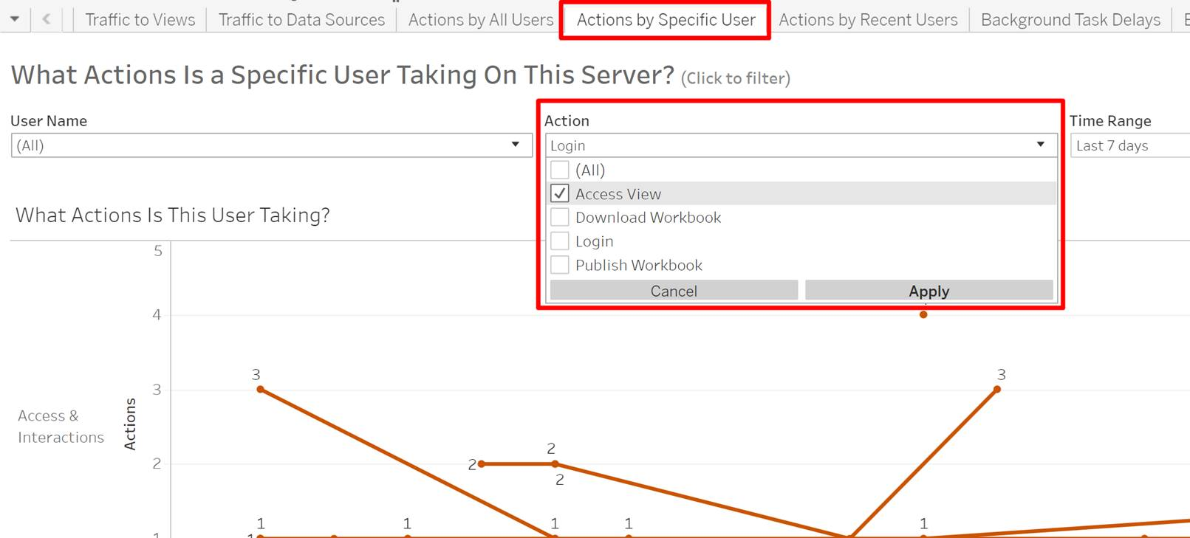

1. To download the underlying data from the filtered report, click on “Download” and select the “Data” option:

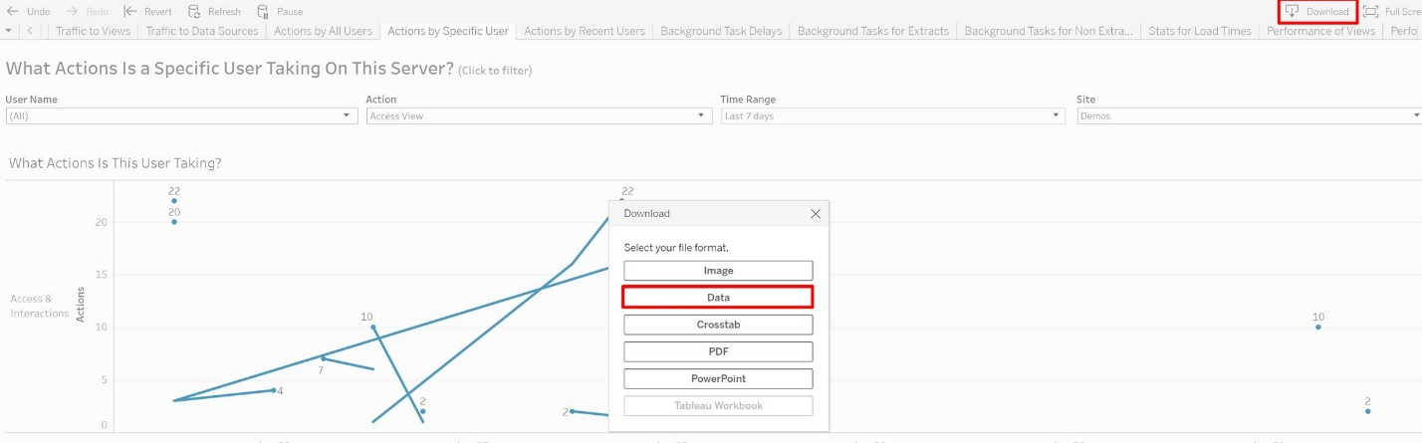

**Note:**

Please note these are tableau server built-in reports and are accessible only to those users who have site role as “Admin”.